**Space/Time**

## Summary

A 3D, multidirectional, time stopping infinite runner.

Lead Designer: Winson Han

|  |  |
| --- | --- |
| Table of Contents |  |
| Story |  |
| Characters and Interactables |  |
| Gameplay Mechanics |  |
| UI/Controls |  |
| Environment/Level/Art |  |
| Music/Sound |  |
|  |  |
| Appendix |  |
|  |  |

## Story

As this is an arcade-styled game, there is not a heavy story element. All the player really knows is that they are some sort of being that is able to fly through the vastness of space and stop time in order to better navigate around hazards and deal with enemies. The player’s time stopping and space flying abilities do imply that the character has unique powers, but there is no deeper meaning in the player’s abilities besides that they are the mechanics.

All the gameplay mechanics implicitly explain more about the player, but details like the player character’s name, reason for flying through space collecting **Temporal Rifts**, and why the **Enemies** are attacking are never revealed and are not important. The focus of the game is on the engaging mechanics and replayable, constantly increasing difficulty scaling that infinite runner type games offer.

## Characters and Interactables

* **Temporal Rift** – These are brightly colored tears in the fabric of space time that the player can collect by running into them. Each rift collected increases their Normal Time movement speed (making the player eventually move fast enough that they will be forced to stop time in order to dodge incoming obstacles), as well as recharge the player’s time stopping ability faster. The movement speed boost from these Rifts are the main way for players to increase their score, as score is based directly on how far they move in space. If the Player collects 5 Rifts, they will heal 1 health. The Player will also immediately gain 1 second of usable Stopped Time for each Rift they collect up to a maximum Overtime of 11 seconds.
* **Asteroids** – These are huge rocks in space that the player must avoid colliding with in order to not take damage. They are rather large when compared to the player, and if the player meets a Large one head on they are forced to stop time in order to maneuver around it. There are small, mid, and large sized asteroids, and asteroids only spawn around the Player during normal time flow.
  + **Small** – These are relatively easy to dodge, even without stopping time and using the limited normal-time maneuverability.
  + **Medium** – These are harder to dodge, and with unlucky placement might force the player into stopping time in order to maneuver around it, but if the player has fast reflexes they will not have to stop time in order to dodge them.
  + **Large** – These are impossible to dodge with the player’s normal time maneuverability, and can only be maneuvered around with time stops. When one of these is in the Player’s path, the player will basically have to stop time in order to change forward directions, otherwise they will be hit and take damage. These large Asteroids might also have holes in them that contain Temporal Rifts, and the player might be lucky enough to “dodge” the asteroid hitting them by going into one of these holes. The player can also stop time in order to aim at the Temporal Rift in the asteroid tunnel more easily.

## Characters

* **The Player** **–** A mysterious being that is seemingly fated to travel through space collecting *Temporal Rifts*, increasing his speed forever. During normal time flow, the player is constantly moving forward at a default speed. The player can influence the direction they are moving with the WASD keys but can only move in the X/Y plane relative to the Camera. The only way for the player to change the player’s forward direction is to stop time, use the Mouse to point in whatever direction they want to move in, then resume time in the new “forward” direction. This will be the main means of movement so the player can dodge Large Asteroids and deal with **Timer** and **Spacer** enemies.
  + **Movement Speed:** As the Player collects rifts, his flying speed increases, causing him to become less maneuverable. The player must use his *Time Stop* in order to change directions when moving at extremely high speeds.
  + **Time State:** The current **Time State** of the game world will always be shown from the player’s perspective. Basically **Time only moves forward if the player is in normal time.** If an enemy is in normal time but the player is in stopped time, the enemy's will appear frozen in space and time. If the player is in normal time but an enemy forces the Time State to switch to stopped time, the Player will be frozen in space, but will still be able to see enemies counting down. In order for the Player to move while an enemy has forced time to stop, the player must enter stopped time himself (meaning he will need stored stopped time that is usable.)
  + **Maximum Duration of Time Stop:** The Player can spend 9 Seconds in stopped time. He will have a stopped time meter that shows how his current amount of stopped time he has available to use.
    - **Collecting Temporal Rifts and Overtime:** Every Temporal Rift the player picks up will immediately add 1 second of stopped time to the player’s current amount of stopped time. If the player is already at their default maximum 9 seconds of stopped time and a Temporal Rift is collected, the player will go into **Overtime,** which allows him to build up additional stopped time up to a true maximum of 11 seconds.
    - **Recharging Stopped Time:** Every second the player spends in normal time will replenish a second of the player’s stopped time up to the default 9 seconds. Time spent in normal time cannot bring the player into **Overtime**, only Temporal Rifts collected if the player is at 9 seconds can.
    - **Stopped Time Mobility**: The player can use the mouse to point in a new forward direction while time is stopped. The player can also click the mouse button to dash forward while time is stopped. This will be the main means of navigating space while time is stopped, as well as dashing into Spacer enemies.
* **Enemies –** There are multiple types of Enemies that the Player can come in contact with.
  + **Spacers –** When these spawn, they will be in front of the Player and remain at a fixed distance if time is flowing normally.
    - **Attack Interval:** While in normal time, Spacers will periodically fire lasers at the Player every 5 seconds. They continue to do this until the player dies from taking too much health, or the Player destroys the Spacer.
    - **Spacers and Stopped Time:** Stopping time allows players to close the gap between the player and the Spacer since the Spacer can only maintain it’s position in front of the player while time is flowing normally. While the Spacer is frozen in stopped time, the player can destroy it by dashing through it.
    - **Spacer Lasers and Stopped Time:** Spacers cannot shoot lasers at the player if time is stopped, as they can only act in normal time. If a Spacer’s laser has been shot at the player, but time stops before it hits, the laser will be frozen in space until normal time resumes. If the player touches the laser in stopped time, the Player will still take damage.
  + **Timers –** These are special enemies that also have the power to stop time. When one of these spawns, the game’s state is immediately forced into Stopped Time. The Player will be frozen in place unless he enters Stopped Time himself. Timers spawn in the same way that Spacers do.
    - **Attack Interval:** Timers, similar to their Spacer counterparts, also shoot lasers at the Player at 5 second intervals. The main difference is that they force the time state to change to Stopped Time before starting their countdown. Once their countdown ends, time goes back into Normal Time as the Timer disappears leaving a Giant Laser in its place. If the time state is in Normal Time, this Laser will instantly travel to wherever the player’s position was when the Timer’s countdown went to 0.
    - **Player vs Timers:** The core of the interaction between the Player and Timers is the choice of when the Player decides to enter stopped time. Since the Timers only have 5 seconds of time to act in `Stopped Time` before they shoot their laser, the Player must carefully time when to enter Stopped Time himself in order to dodge the laser.
      * For example, let's say the Player has only has 3 seconds of Stopped Time currently usable. The Player is dodging asteroids in normal time, when suddenly a Timer appears and forces the time state into Stopped Time. The Timer’s laser begins counting down from 5 seconds, but the Player panics and enters Stopped Time himself at the Timer’s 4 second mark. The Player, however, only has 3 seconds left to act within Stopped Time. As the Player runs out of stopped time, the Timer still has 1 second to act while the Player is now “stuck” back in normal time and frozen due to being out of stopped time. Once the Timer finishes counting down, time will resume to normal and the Giant Laser the tier leaves behind will hit the player since the Player’s last known location is where the player was frozen due to the Player running out of stopped time before the Timer.
      * In the above example, the Player should have waited until the Timer’s countdown was at least at 2 seconds to active his own stopped time, so that the Timer would run out of stopped time first, thus allowing the player to dodge the laser. Since the Timer stops tracking where the player’s location is once its countdown reaches 0, the Player has 1 second to move to a different place in space to avoid the Giant Laser that will fire once all characters have exited stopped time and normal time has resumed.
      * For a specific example of the time stopping, back and forth combat between the Player and the Timers, please reference the Jotaro vs DIO fight in JoJo’s Bizarre Adventure Part III: Stardust Crusaders. The way Jotaro handle’s DIO’s time stopping abilities very much inspired the way this mechanic works: <https://youtu.be/mO4z_2J2mmU>

## Gameplay Mechanics

### Health and Death

The player starts with **5 Health**. Every time the Player is shot with a Laser or hits an Asteroid, they will lose a health. For every 5 Temporal Rifts the Player collects, he will replenish his health by 1. If the player is already at 5 Health and they gather 5 Rifts, they can increase their health as **Overhealth** up to a maximum of **10 total health**(5 Health and 5 Overhealth).

### Time States and Energy

There will be two main “states” that time can be in: ***normal*** and ***stopped***. Different objects in the world may be in different states simultaneously, but time’s current state will always be shown from the perspective of the player. By default the player starts the game in Normal Time, flying in the player’s local forward direction at a set speed that will increase as more ***temporal rifts*** are gathered.

#### Normal Time

While the player is in Normal Time, they will constantly and indefinitely be flying in the current “forward” Z direction with limited X and Y axis mobility. In this time state, the Player’s world Z axis direction cannot be changed, only their X and Y positions. The faster the player is moving, the more limited the Local X and Y maneuverability. In order to change World Z directions and effectively pull off sharp turns in Space, the player must enter Stopped Time.

The player will also continuously regenerate usable **Stopped Time** for as they spend time in **Normal Time**. This is not limited to integer values of time spent in normal time. If the Player only spends 0.2 seconds in normal time, they will gain back 0.2 seconds of usable Stopped Time, and so on for any denomination of time.

Asteroids will randomly and infinitely spawn in front of the player. The small and medium ones can be dodged, however large asteroids can not be dodged with the limited X Y movement the player has access to in Normal Time. Large Asteroids can ONLY be dodged utilizing **Stopped Time** in order to change their forward direction.

#### Stopped Time

While in Stopped Time, the Player loses the ability to move in their world X and Y directions, but instead gain the ability to rotate around 360 degrees with the mouse in order to change their current “forward” Z direction. The player no longer moves constantly forward during stopped time, but can dash in whatever new “forward” is oriented. This dancing between Stopped and Normal time will be the only way for players to avoid Large Asteroids as well as destroy Spacers that spawn.

The following are some representational images of how Normal and Stopped Time will be perceived by the Player. Please Note the difference between the **Player’s (Red Axis) Local Directional Orientation** and the **World Orientation (Black Axis).**

The World Orientation will effectively remain constant, as **Asteroids** will remain locked in their **World Coordinates** when time is stopped, but **the Player** will be able to freely manipulate their local orientations and positions while time is stopped.

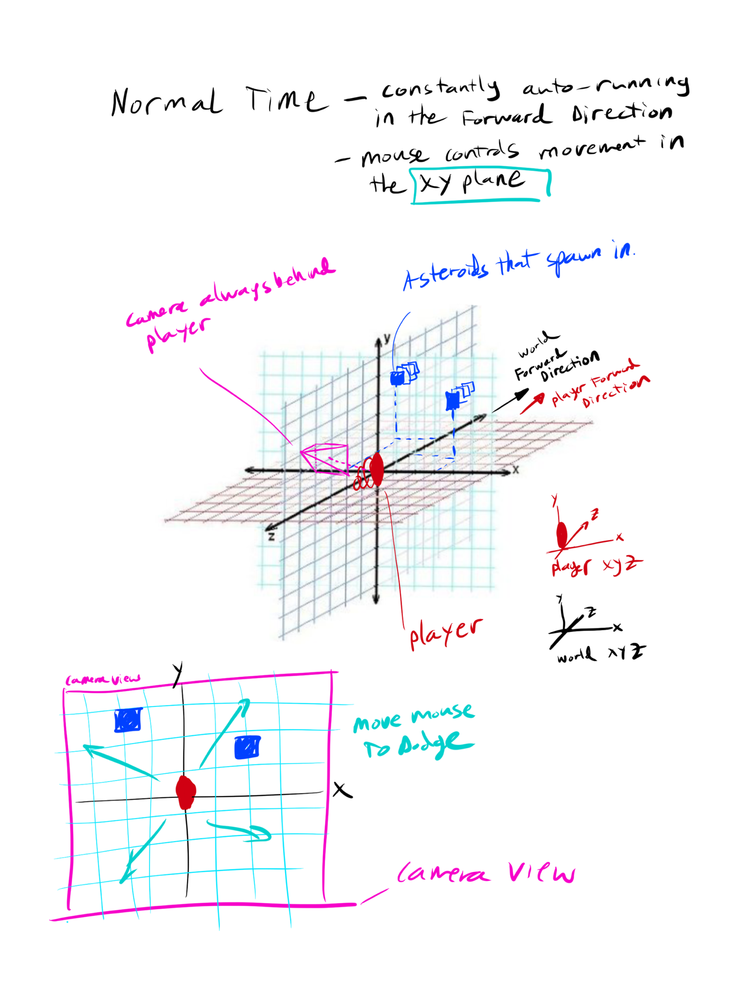

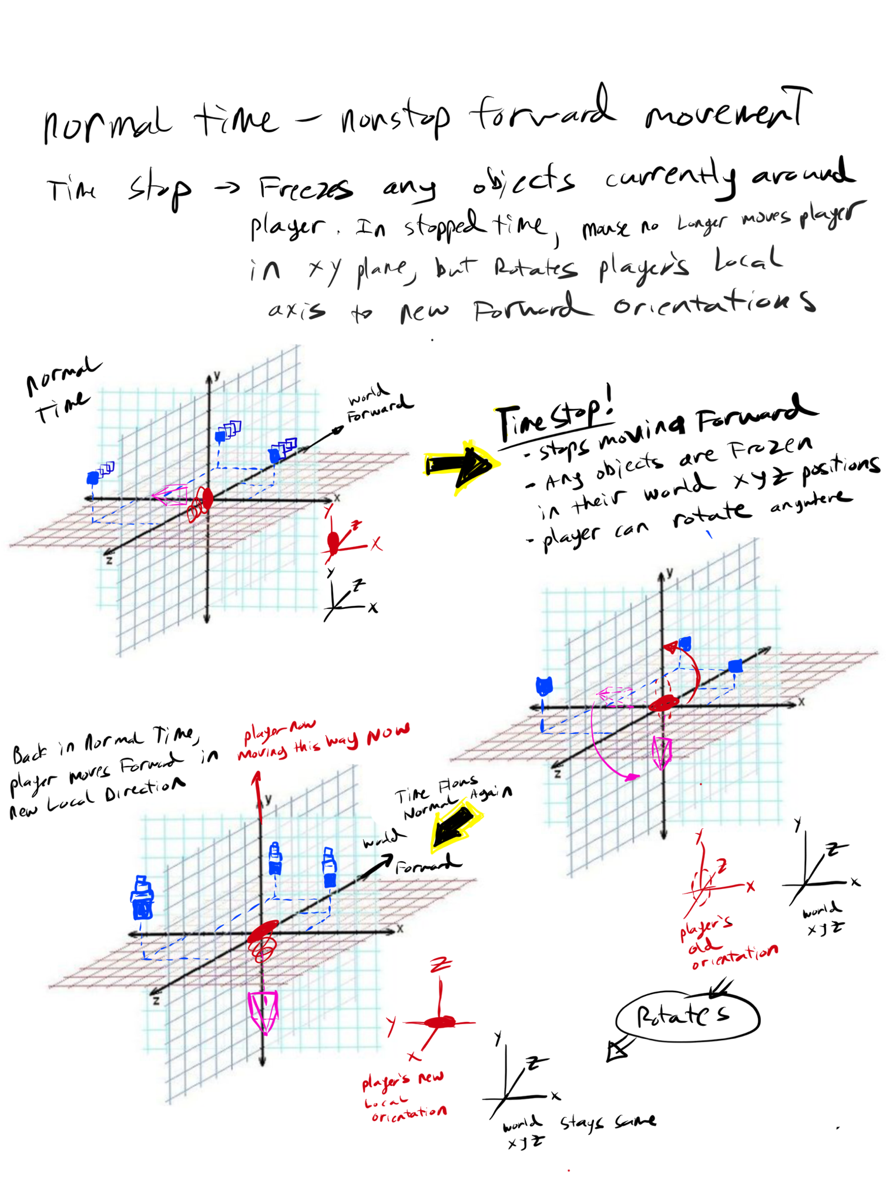

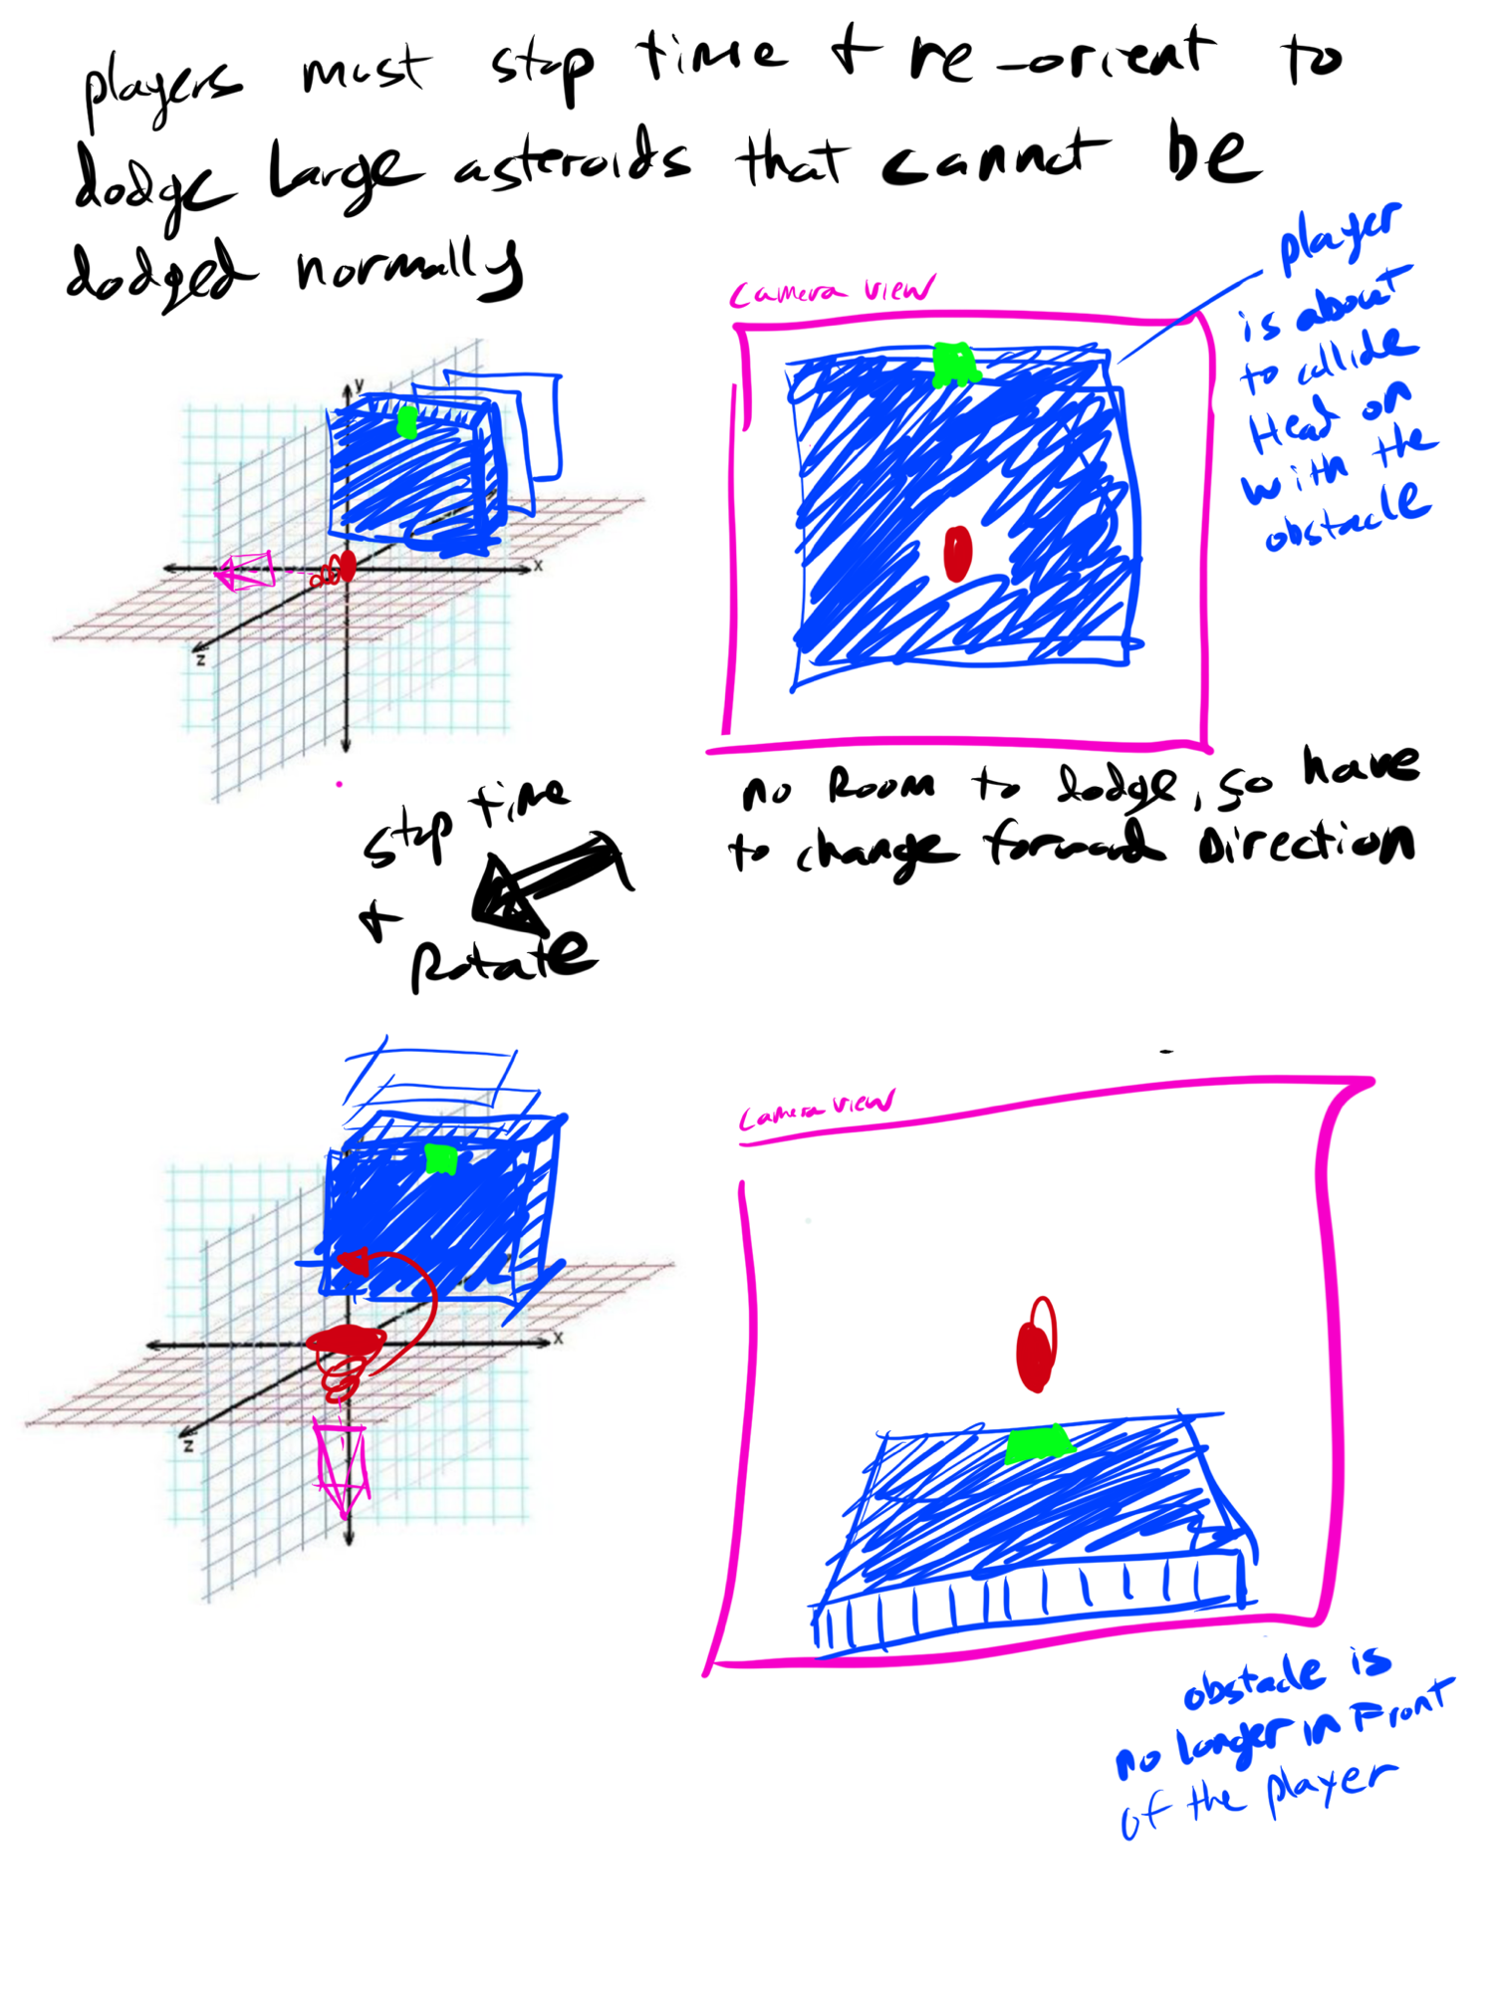

## UI/Controls

### CONTROLS

Toggle Stopped Time

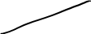

Dash Attack (Stopped Time Only)

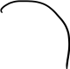

The entire game can be controlled with only a Mouse and the WASD Keys.

During Normal Time, the Player uses WASD as input for the player’s X and Y plane movements.

To Toggle the Player’s Stopped Time state, click the left mouse button. The right mouse button will do nothing in Normal Time, but in Stopped Time it will be the forward dash.

### HUD

There are 4 Major HUD components that need to communicate information to the Player.

1. Health
2. Distance Traveled
3. Amount of Stopped Time currently usable
4. Arrows pointing to any offscreen Enemies (like in The Star Wars Starfighter games)

## Environment/Level/Art

There will only be one effective “level” that is procedurally generated as the player infinitely flies forward. The level will have various asteroids, Enemies, and Temporal Rifts that spawn at increasing rates the longer the player survives.

The feel of the environment will very much rely on visuals and colors of the space. The Stars in the background of Space are not going to be simply white twinkles on a black space backdrop. Instead, the Color palates and aesthetic are to be based on bright, vibrant colors like those found in Geometry Wars or Rez.

The look of our Player and Enemies is also to be inspired by Rez. The simple, geometric figures is the aesthetic of the 3D models we want to use for the game.

Finally, the Visualizer aspects of Rez is another environmental detail that we will be drawing inspiration from. The game will have 3 different Color Palates for every single object in the game. All objects on screen (characters, enemies, particles, asteroids, even the UI) will cycle between the 3 color palates to the beat of the music. On top of this, a Bar based visualizer will be present in the background of our space that will also visualize to the beat of the music.

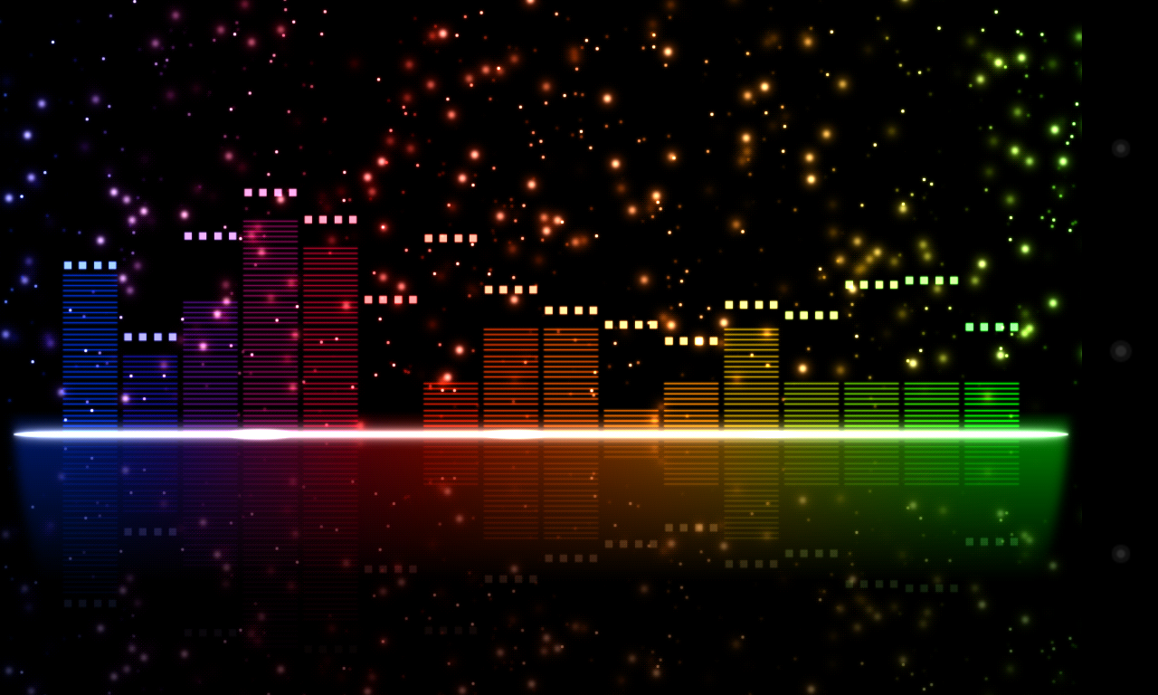

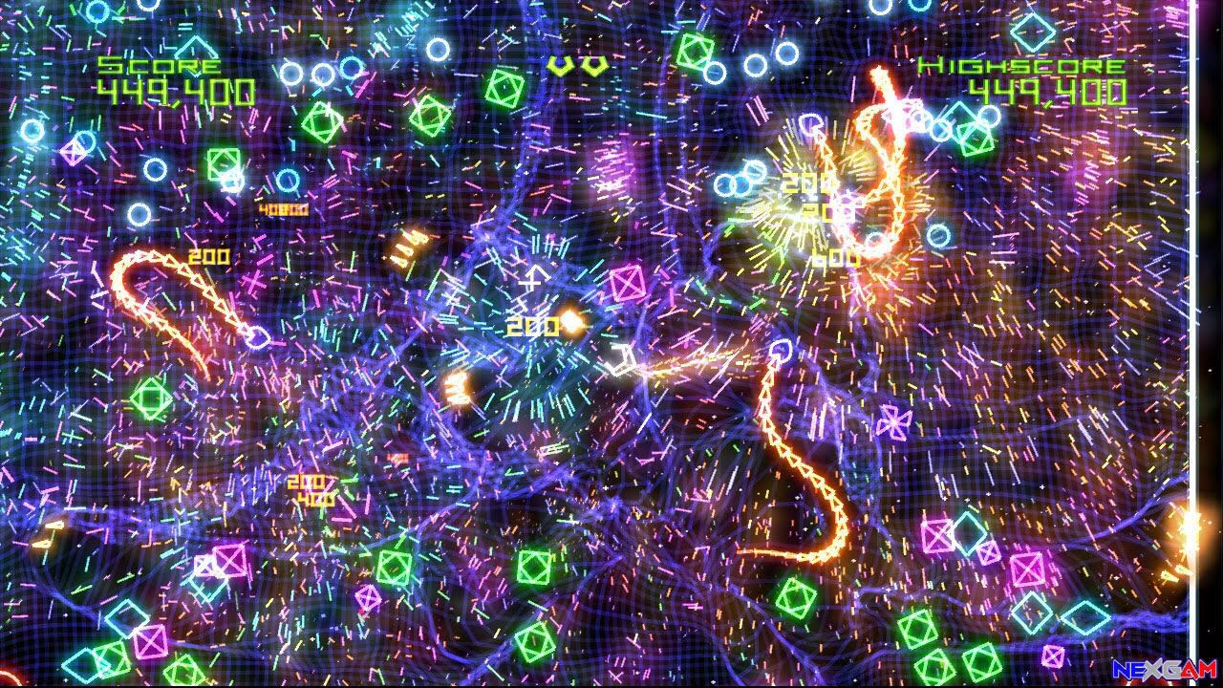

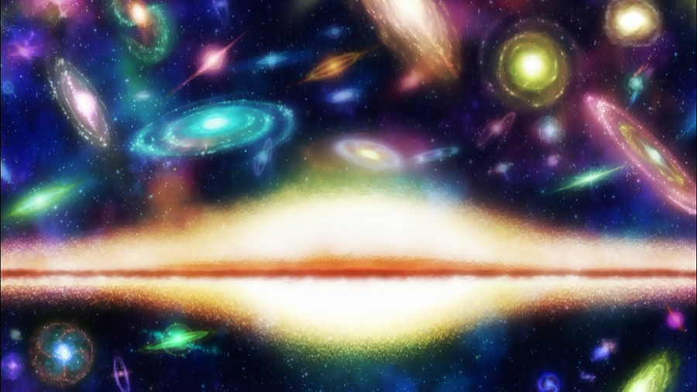

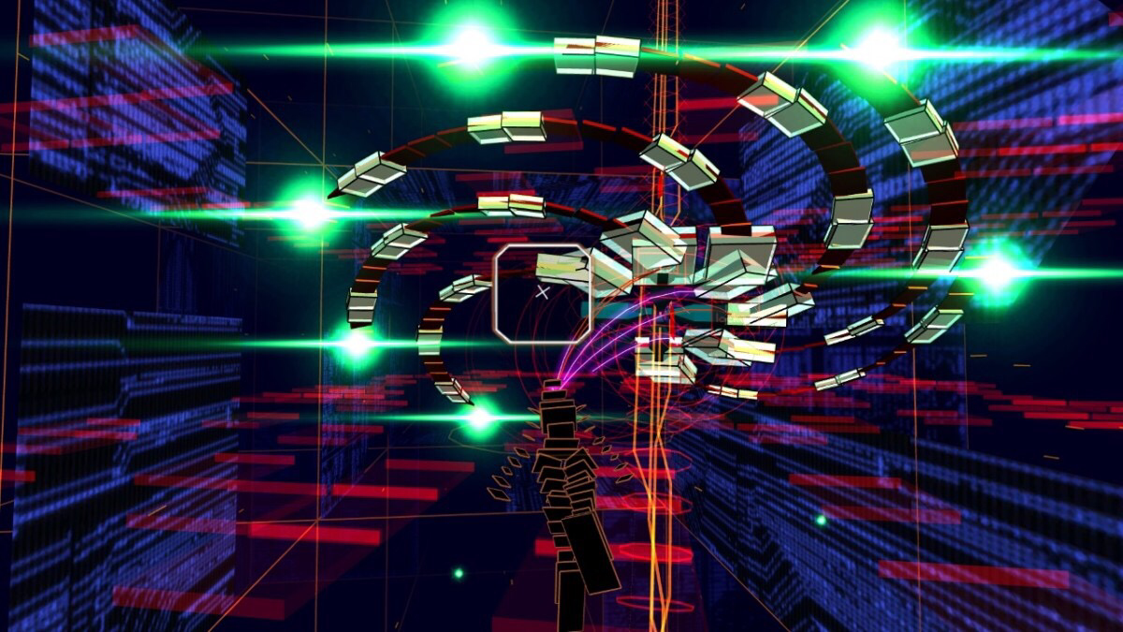

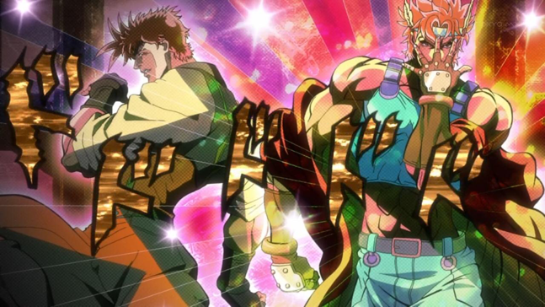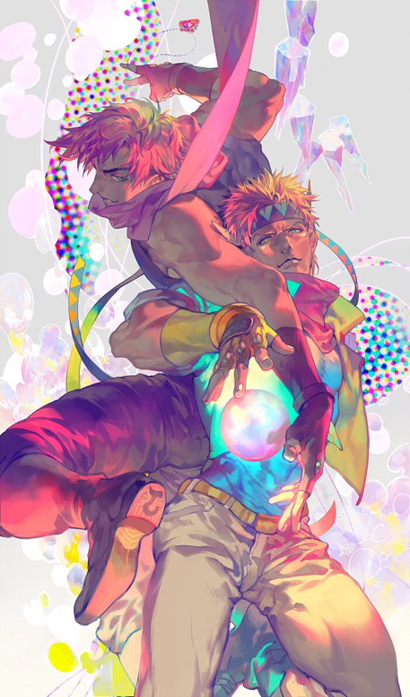

## Music/Sound

Initial ideas for music are very fast, upbeat songs that are in the Electro Swing, Electronic, or 8-bit style. While Time is Stopped, the music tracks should stop and there will be a muffled, echo-like effect that plays the entire duration of time stopped (think similar to “I’m underwater and things are echoey and muffled” sort of feel).

As far as sound effects go, the most important one to have is a “Clock Ticking Slower” sort of effect that plays when time switches to Stopped, and a “Clock Ticking faster up to speed” sort of effect for when Time goes back to normal time.

The following are a few references for the style of music we want our tracks to have.